NAME: KRINA PANCHAL

1)My role is to make a expense tracker

2)I was learning JavaScript

3)Nope, I didn’t take any course but I did take a lot

of help from YouTube and google

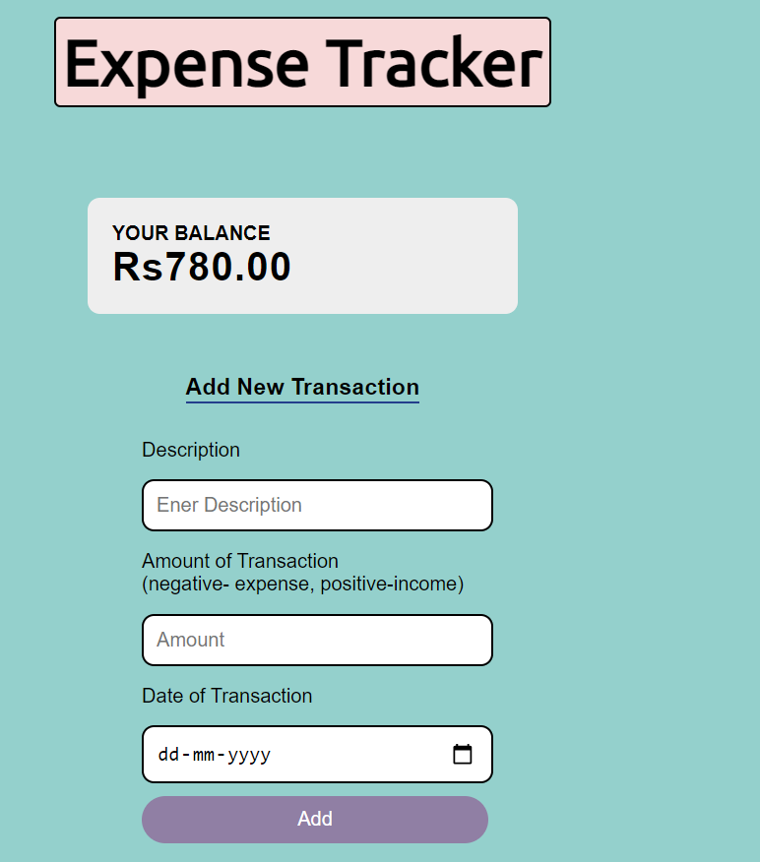

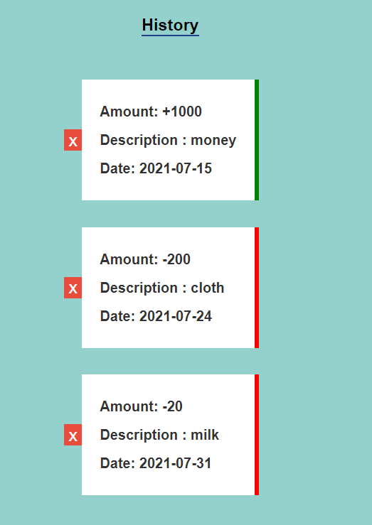

Github repo link: https://github.com/krina1912/expense-tracker